**In place upgrade tickets**

The following Service Request template needs to be used going forward for any In place upgrade ticket logged in Service Now: [Link](https://apac01.safelinks.protection.outlook.com/?url=https%3A%2F%2Fpgglobalenterprise.service-now.com%2FITSM_Portal%2Fcatalog-item.do%3Fsysparm_document_key%3Dsc_cat_item%2C134a191d4fe03a00742fdbb5f110c736&data=02%7C01%7Cizabela.paruzel%40hcl.com%7C2e6e7d2ddad64795092c08d670d9cbdd%7C189de737c93a4f5a8b686f4ca9941912%7C0%7C0%7C636820478061904631&sdata=LTmCpLyxVapulWTPQJv3zlwz9Sr8BQShiJ%2FfqvKdgG0%3D&reserved=0)

Steps to fill it in:

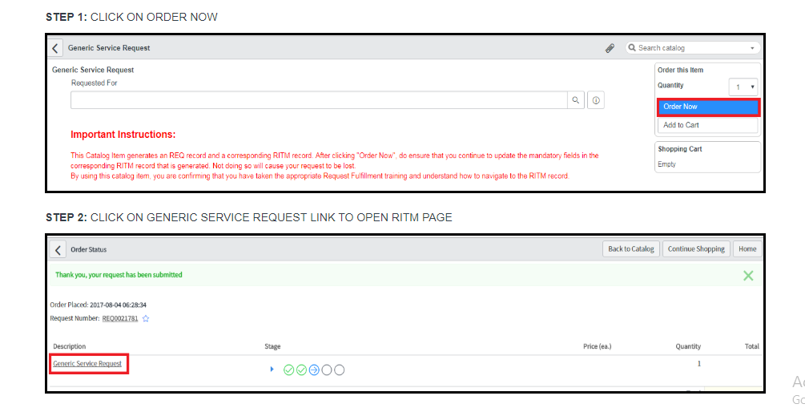

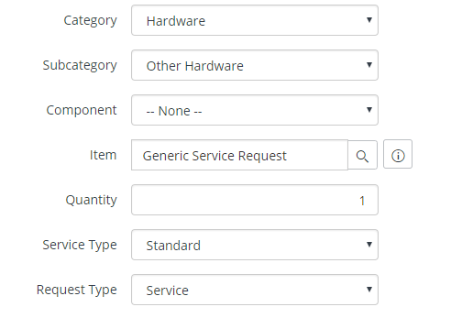



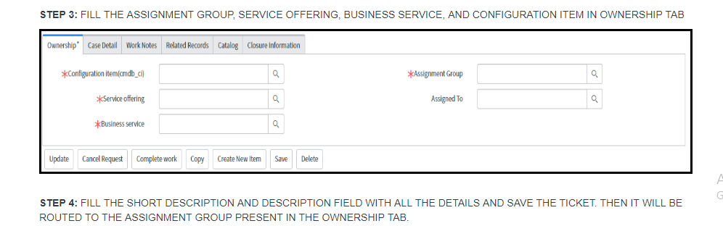

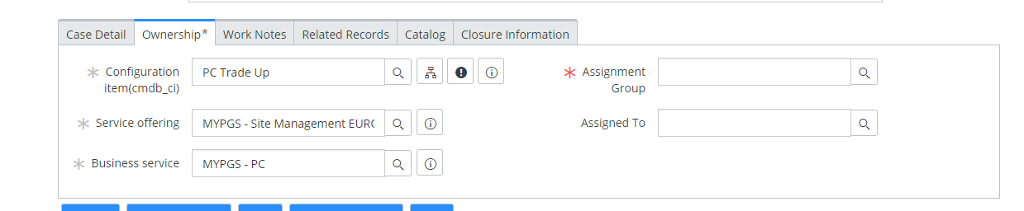

The request needs to be manually assigned to one of the following queues, depending on the region. There is no SLA attached to this SNOW form.

1. HCL_MYPGS_NA_PCTU_PROJECT

2. HCL_MYPGS_EU_PCTU_PROJECT

3. HCL_MYPGS_LA_PCTU_PROJECT

4. HCL_MYPGS_ASIA_PCTU_PROJECT

5. HCL_MYPGS_IMEA_PCTU_PROJECT

**PCTU tickets**

The following Service Request template needs to be used going forward for any In place upgrade ticket logged in Service Now: [Link](https://apac01.safelinks.protection.outlook.com/?url=https%3A%2F%2Fpgglobalenterprise.service-now.com%2FITSM_Portal%2Fcatalog-item.do%3Fsysparm_document_key%3Dsc_cat_item%2C134a191d4fe03a00742fdbb5f110c736&data=02%7C01%7Cizabela.paruzel%40hcl.com%7C2e6e7d2ddad64795092c08d670d9cbdd%7C189de737c93a4f5a8b686f4ca9941912%7C0%7C0%7C636820478061904631&sdata=LTmCpLyxVapulWTPQJv3zlwz9Sr8BQShiJ%2FfqvKdgG0%3D&reserved=0)

Steps to fill it in:







PCTU Upgrade





The request needs to be manually assigned to one of the following queues, depending on the region. There is no SLA attached to this SNOW form.

1. HCL_MYPGS_NA_PCTU_PROJECT

2. HCL_MYPGS_EU_PCTU_PROJECT

3. HCL_MYPGS_LA_PCTU_PROJECT

4. HCL_MYPGS_ASIA_PCTU_PROJECT

5. HCL_MYPGS_IMEA_PCTU_PROJECT

**Important note:**

**There are 3 conditions that trigger the survey and they need to be followed in all tickets:**

**In place:**

* Status changes to Closed Complete
* Item = Generic Service Request
* Assignment Group =
  1. HCL_MYPGS_EU_PCTU_PROJECT
  2. HCL_MYPGS_ASIA_PCTU_PROJECT
  3. HCL_MYPGS_IMEA_PCTU_PROJECT
  4. HCL_MYPGS_LA_PCTU_PROJECT
  5. HCL_MYPGS_NA_PCTU_PROJECT
* Short Description contains **In place upgrade**

**PCTU:**

* Status changes to Closed Complete
* Item = Generic Service Request
* Assignment Group =
  1. HCL_MYPGS_EU_PCTU_PROJECT
  2. HCL_MYPGS_ASIA_PCTU_PROJECT
  3. HCL_MYPGS_IMEA_PCTU_PROJECT
  4. HCL_MYPGS_LA_PCTU_PROJECT
  5. HCL_MYPGS_NA_PCTU_PROJECT
* Short Description contains **PCTU upgrade**